**Name :**

**Dawood Sarfraz**

**Roll no :**

**P20-0153**

**Section :**

**BSCS 5B**

**Course :**

**Computer Networks**

**Lab # : 13**

**➔Implement the S-NAT for web server of (flex and slate) and**

**Dynamic-NAT for Client Systems in a single topology.(Use**

**routers and switches).**

**Topology:**

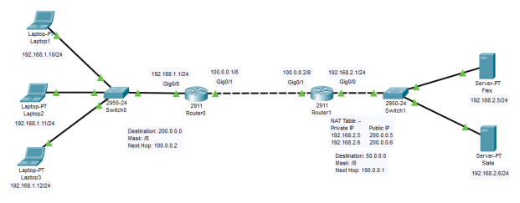

**PC configuration :**

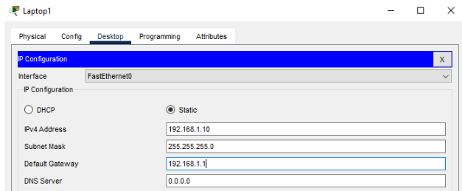

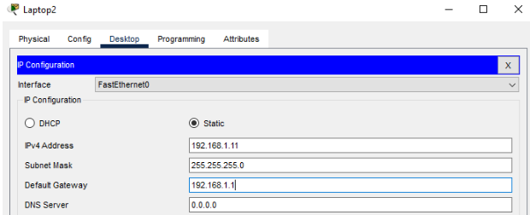

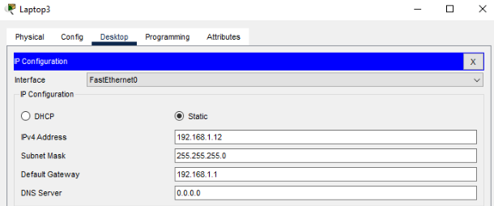

**Server Configuration :**

**Flex:**

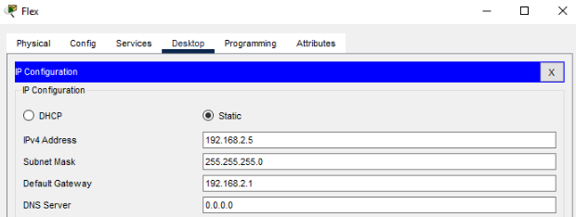

**Slate:**

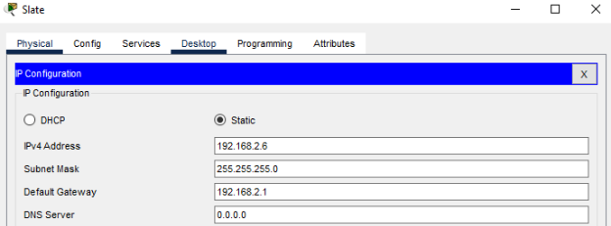

**Router Configuration :**

**Router0 :**

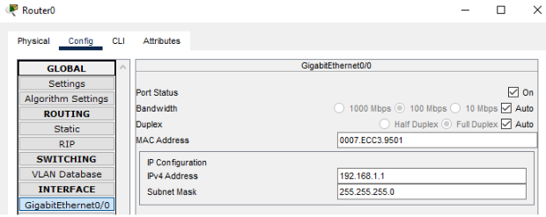

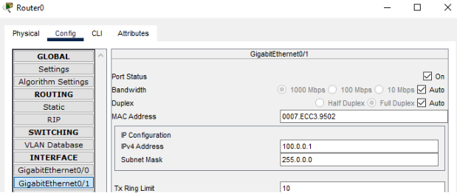

**Router1 :**

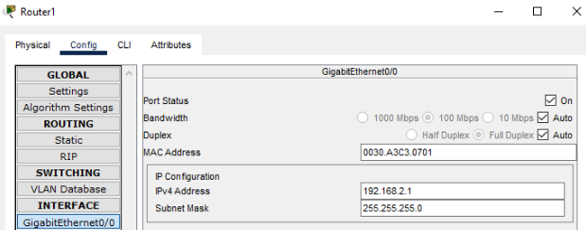

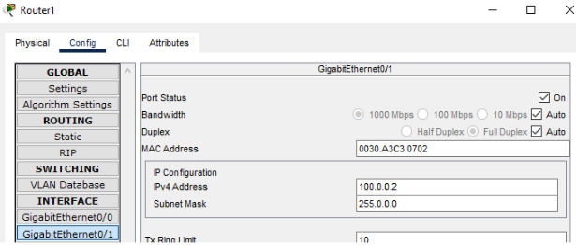

**Configure Dynamic NAT:**

**For Router0 :**

**Dynamic NAT configuration requires four steps: -**

**1. Create an access list of IP addresses which need**

**translation:**

**In this step we will create a standard access list which defines**

**which inside local addresses are permitted to map with inside**

**global address.**

**To create a standard numbered ACL following global**

**configuration mode command is used:-**

**Router(config)# access-list ACL_Identifier_number permit/deny**

**matching-parameters**

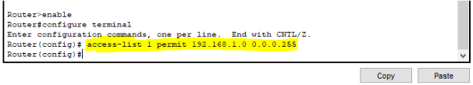

**2. Create a pool of all IP address which are available for**

**translation:**

**In the second step we define a pool of inside global addresses**

**which are available for translation.**

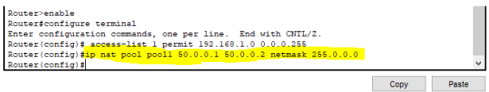

**3. Map access list with pool :**

**In the third step we map access lists with pools. Following**

**command will map the access list with a pool and configure the**

**dynamic NAT.**

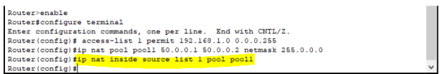

**4. Define inside global interface:**

**In the fourth step we have to define which interface is**

**connected with the global network and which interface is**

**connected with the local interface .Following command will**

**define interface Gig0/1 as inside global.**



**Testing Dynamic NAT Configuration :**

**To test this setup click Laptop 1 and Desktop and click**

**Command Prompt.**

**● Run ping 200.0.0.5 command.**

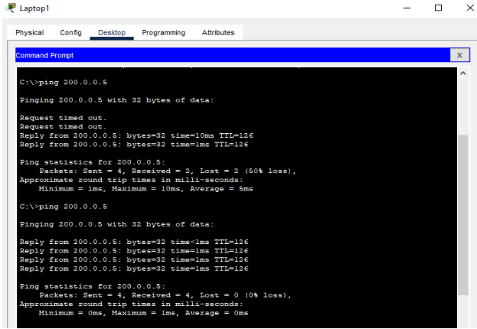

**● Run ping 192.168.2.5 command.**

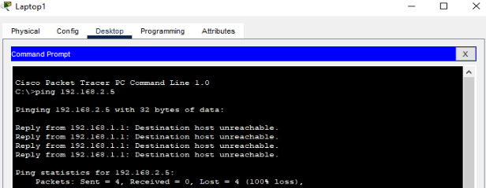

**This Command gives the error “Destination Host Unreachable”**

**because we are trying to access a remote device on its local IP**

**address which is not possible because we can access remote**

**devices only on their Public ip addresses.**

**Creating File & putting it on Flex Server:**

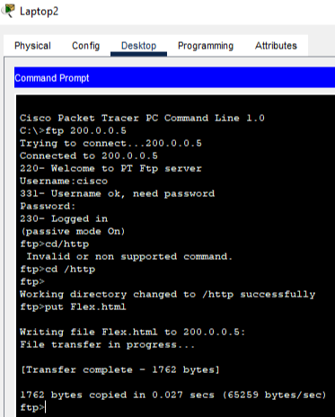

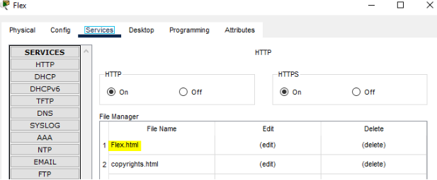

**Doing the last testing. Click Laptop1 and click Desktop and click**

**Web Browser and access 200.0.0.5.**

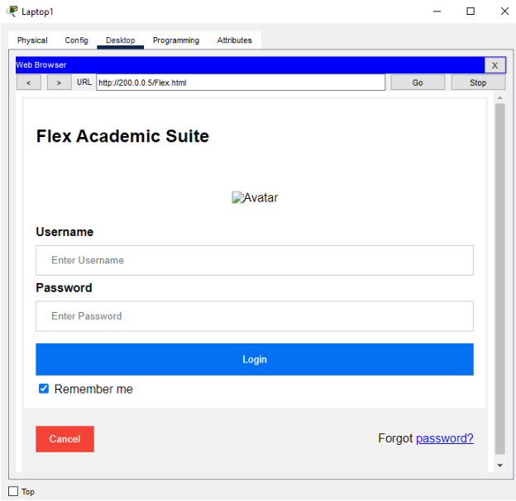

**Above figure confirms that host 192.168.1.10 is able to access the 200.0.0.5.**